**Protocol and evaluations**

Authors:

TEDyBEAR Center: Jacqueline NADEL

This project was carried out within the framework of the MIMETIC project "Software for training combined with collaborative social interaction and motor learning in Autism Spectrum Disorder".

This project is a winner of the Call for Autism and New Technologies projects, coordinated by FIRAH and supported by the Orange Foundation and the UEFA Children's Foundation.

Work done by:

 

TEDyBEAR and LIMSI-CNRS

The project was supported by: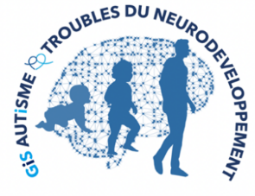





Web sites:

<https://mimetic.limsi.fr/>

<https://www.firah.org/fr/logiciel-pour-l-entrainement-combine-a-l-interaction-sociale-cooperative-et-a-l-apprentissage-moteur.html>



The FIRAH is a Foundation recognized as a public utility, which wishes to put research at the service of actors in the field. It is chaired by Patrick Gohet.

It is to meet the needs and expectations of people with disabilities that FIRAH was founded and that it develops today around these activities:

* Support applied research projects on disability.
* To stimulate the valorization of the results of this research in particular with the actors in the field.
* Animate the dissemination of knowledge on disability produced throughout the world.

<http://www.firah.org>

Tedybear 

Tedybear is a group of experimental medical-social centers dedicated to the education of young children with Autism Spectrum Disorder (ASD) between the ages of 3 and 11, most of whom are non-verbal. These centers are approved by the ARS d'Ile de France. One is located in Saint-Cloud, the other more recent one is in Paris. TEDyBEAR has developed an innovative pedagogical concept based on inclusive education and coordination with family and caregivers.

With the objective of school inclusion: Sharing of time between the school and the center; Coordination with the school: participation in the ESS, GEVASCO, implementation of liaison notebooks, visits to the center by teachers and AVS, and by liberal therapists (speech therapist, psychomotricist, occupational therapist).

In the objective of coordination with the family: Educational booklet given out each weekend with weekly sheet from the referring psychologist, monthly curves of positive and negative behaviors; weekly sheet from the educators providing information on autonomy and social adaptation to peers; daily relay table to the families showing clips of the day; In return, weekly sheet filled out by the parents and providing information on behavior at home during the week.

Tedybear works in 1/2/3: one child for a psychologist during the therapies, 2 children for a psychologist for the pedagogical activities, 3 children for an educator for the activities relaying with the school in the field of socialization.

The pedagogical work is of the neuro-educational type with the social brain exercise as a base. A particular focus is placed on imitation, which is central to development in that it is closely related to major functions, perception, action, language, and is the initial support for communication and learning. Therapies are of two types: imitation to develop non-verbal communication and observational learning, and kinect to develop body awareness and calibration of spatial organization.



LIMSI-CNRS (www.limsi.fr, BP 133, 91403 Orsay).

The Laboratory of Computer Science for Mechanics and Engineering Sciences is a multidisciplinary research laboratory that brings together researchers from different disciplines of Engineering and Information Sciences as well as Life Sciences and Social and Human Sciences. Administratively, the LIMSI is a CNRS unit, attached to the Institute of Information Sciences and their Interactions of the CNRS.

Research in human-computer interaction is interested on the one hand in analyzing, understanding and modeling the interactions between humans and artificial systems. The CPU group involved in this project focuses on the psychology of non-verbal and collective affective interactions in humans as well as on the design of affective and virtual human-computer interfaces. The members of the group are teacher-researchers from the University Paris-Saclay in Computer Science, Human-Computer Interaction and Psychology.

Several projects concern the training of social skills for (children, adolescents and adults; with or without pathology) such as the design of virtual characters for training job interviews or training of health care staff using virtual patients. Researchers participate in the definition of theoretical frameworks, the design of human-computer interactions and their experimental evaluation.

**Outline**

Summary 5

Protocol 6

Familiarization 6

Training to use the tangible object in relation to the virtual object with Michou 7

Training to adapt one’s movements to Lola’s leading movements 7

Evaluations conducted with the software with the participation of associations and actors in the field, especially parents and siblings 8

Global aspects 8

Participants 8

Familiarization with the procedure 13

Training with Michou 15

Training with Lola 16

Special difficulties 16

What was learnt 17

Limiting overall results 18

Dealing with individual events 19

Références 22

Appendix : Report to the parents of child 111 (we replaced the first name with X in the text). 24

# Summary

The virtual platform aims at simulating joint action between a child and a virtual character. It is composed of a virtual character projected on a vertical surface on which a tangible object is magnetized: both the child and the virtual character *“hold”* and move the object enabling the simulation of a joint action. The child can hold and move the tangible object. The virtual character can move what looks like the graphical part of the tangible object. The projected wall is a window on the virtual space of the virtual character assumed to be the continuity of the real space of the participant, participants can *“see through”* the wall.

Three objects representing a table (in purple), a stool (in red) and a box (in blue), were designed. Each tangible object holds on the wall as it is magnetized to a twin object located behind the wall (cf Figure 1). As the child slides the front object along the wall, the corresponding twin object hidden behind the wall follows. Thanks to this principle, the tracking can be embedded in the twin object and be hidden to the child.

The anthropomorphic virtual characters were designed without facial features and expressions to limit the social complexity of the virtual scene. As the training implies to interact in two modes (a follower and a leader mode), two different virtual characters were designed differentiated from the other by a different color and hat (Figure 1.a). Attributing a specific role to an identifiable character enables to simplify the social interaction as well as bring some appealing variability to the training. Names were given to each character to personify them and facilitate oral instructions for practitioners (i.e., “Michou” for the following character, “Lola” for the leading character).

The bodily interaction was kept as simple as possible. While doing nothing, the character is animated by an idle animation. On demand of the practitioner, the virtual character can grasp a virtual object. Two interaction mode were designed:

* Following mode: the character holds the virtual object which stays aligned to the tangible part. The child has to lead a movement toward a specific target instructed by the practitioner. In Figure 1b, the instruction is to move with Michou the blue box from the purple table to the red stool.
* 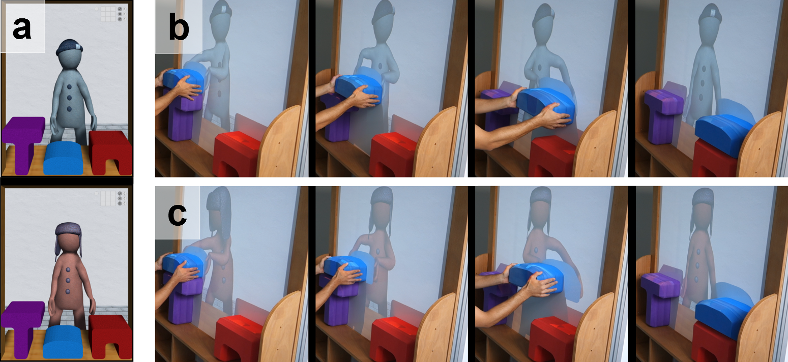Leading mode: the character initiates a movement with the virtual part of the object which visually detaches itself from the tangible part of the object. The child has to follow the character’s movement toward a specific target that is unknown to the child. If the child does not follow close enough the virtual object, the leading character releases the object and a smoke animation is displayed around the virtual part of the object. In Figure 1c, the instruction is to move with Lola the blue box by following Lola (without specifying the destination).

*Figure 1- The virtual characters Michou (top image left) and Lola (bottom image left)*

*and the 3 tangible objects*

Within each training session, a scenario corresponds to the task of moving a specific object to a specific target along with the virtual character. The practitioner controls the types and the quantity of scenarios he/she wants to run with the child. A scenario is automatically considered a success (with stars displayed and rotating around the virtual part of the object) when the tangible object held by the child reaches the target. It is automatically considered a failure (with a soft smoke animation) if the child does not succeed to follow the leading character properly.

# Protocol

The general procedure is an individual procedure in three stages designed by the developmental psychopathology team: familiarization, training to move the object with Michou, the agent that follows the child, and then training with Lola, the agent that the child must follow.

## Familiarization

First, each child is invited to enter the room that contains the tangible-virtual platform. Usually this room is reserved for another use. The child must therefore get used to the fact that there is a different layout of the room than usual since there is a new device in it. This may take several sessions (the child may refuse to enter, may want to open the platform or sit on the partition, etc.).

## Training to use the tangible object in relation to the virtual object with Michou

Once the place and device are accepted, we move on to train the child to the use of the tangible object in relation to the virtual object of the following agent Michou. Spontaneously the children take the real object into their own hands. The first step is to make them understand that they have to drag the object along the wall in relation to the virtual object held by the avatar Michou. This first step is more or less long for the children.

A second difficulty is to maintain the goal of moving the object together with Michou all along the route designed by the scenario. For Michou to follow, the child must control throughout the scenario that the adhesion between the real object and the virtual object is maintained. In addition to train gross motor skills required to slide the object along the wall, testing and training the ability to maintain a goal is thus part of the therapies that can be used with the device. As we know the capacity to maintain a goal is often lacking in autism spectrum disorder.

A third difficulty of the collaborative task is that the child has to perform 4 scenarios on a record, representing 4 different routes: hoisting the box on the floor to the table; slide the stool next to the table; take the box on the table and place it on the stool; take the box on the stool and place it on the floor. The instruction is verbal for children with a small language, and modeled for non-verbal children. It is therefore necessary for the children to understand and follow the instruction, even if they would like to make their own route. It is about being able to inhibit your internal motivation to follow external motivation, whereas this ability to control activity is often very low in our children. The device therefore offers the therapeutic opportunity to train these executive difficulties. The training phase is effective if the four needs are respected: drag the tangible object along the wall instead of taking it in hands, make the tangible object to adhere the real object, maintain the grip throughout the route and not to give priority to its own motivation.

## Training to adapt one’s movements to Lola’s leading movements

Once the collaboration with Michou is completed, the training to collaborate with Lola (the leading agent) can begin. The great difficulty for the child is to follow Lola who is self-reliant. Lola chooses the object she wants to move, so you have to understand Lola's choice. Lola chooses a scenario, so we must deduce the direction she will take on the basis of the orientation of her posture. Lola chooses the target of the move, i.e. where to place the object, so the child must analyze her posture as indicating the trajectory of movement (up, bottom, right, left). Lola chooses the speed of her movement among 3 possible speeds: the speed of the child when he was driving the scenarios (i.e. the easiest speed to follow), the fast speed that forces the child to accelerate to follow Lola, and the slow speed, the most difficult to follow because it requires the child to control his motor skills not to exceed Lola, which would lead to failure. The three speeds are presented in the order of increasing difficulty. As a matter of fact, the real test of synchronization abilities on the movement of the other is to move the object with the agent.

# Evaluations conducted with the software with the participation of associations and actors in the field, especially parents and siblings

*Usually, the Tedybear Centre organizes 'siblings’ days’ during school holidays with the possible presence of the family. At the end of 2019, the transport strike reduced the presence of children at the centre and the possibility of organizing siblings' meetings. The lockdown in mid-March made such meetings definitely impossible**. In order to exchange with families about the software, we carried out reports on their child's activity and progress with the virtual platform. We give an example of the report and the reaction of the family at the end of the summary report.*

The summary report will first describe the general elements that occurred many times during the 44 sessions gathered, Each session consisting of several scenarios, themselves giving rise to many events, the number of tests reaches the total of 633 and thus allows to highlight generalities. We will then present a focused approach to individual events as an example of a background micro-analysis work for the publication of an article in a specialized journal.

## Global aspects

### Participants

The device was presented to 12 children from 4a11m to 9a4m (My chronological age: 7a0 and median 6a6m) with a follow-up of sessions corresponding to the performance achieved. Ten of these children are between 6a4m and 7a5m (My-7a, median: 6a11m). Of these 12 children, 7 have a small conversational language. All but the youngest are able to recognize being imitated, which corresponds to a useful self-recognition to discriminate against Michou's follower mode of Lola's leader mode. Developmental ages measured with the non-verbal test of Raven's Colored Matrixes (Raven, 1998) are between 6 years 6 months and 7 years for verbal children.

**Enfants CA DA L RBI**

**204 96 83 V** **3**

**111 83 84 V** **3**

**105 83 73 V** **3**

**106 77 64 V 2**

**108 89 80 V** **2**

**112 76 70 V** **2**

**201 78 56 V** **3**

**109 78 58 NV**  **3**

**103 112 60 NV 2**

**102 90 48 NV**  **1**

**110 77 58 NV**  **1**

**113 59 36 NV**  **0**

*Table1- Participant Characteristics: Chronological Age (CC), Developmental Age (DA), Language (Verbal/Non Verbal); Recognition of being imitated (RBI)*

As Table 2 shows, only 4 children were able to collaborate with Lola, the autonomous agent. For these children, there were more trials with Lola, which indicates the difficulty of collaborating with the agent to follow.

But how do you explain the difficulty faced by 8 of the 12 children in successfully training with Michou?

The language variable is not decisive for success because of the 7 children who have a small conversational language, only 2 result in the completion of the 3 tasks Lola, while among the 5 non-verbal, one succeeds perfectly and completely the 3 tasks Lola with a learning preserved 3 weeks after the stop of training (S109).

|  |  |  |  |
| --- | --- | --- | --- |
| Trials  Subjects | TotalN of trials | N trials with Michou | N trials with Lola |
| 109 (NV) | 133 | 12 | 121* |
| 111 (V) | 217 | 28 | 189 |
| 204 (V) | 122 | 4 | 118 |
| 105 (V) | 78 | 38 | 40 |
| 106 (V) | 31 | 31 | 0 |
| 110 (NV) | 15 | 15 | 0 |
| 112 (V) | 14 | 14 | 0 |
| 103 (NV) | 8 | 8 | 0 |
| 102 (NV) | 6 | 6 | 0 |
| 108 (V) | 5 | 5 | 0 |
| 201(V) | 4 | 4 | 0 |
| 113 (NV) | 0 | 0 | 0 |

TOTAL 633 165 468

*Table 2- Total number of trials per child and their distribution by virtual partner*

*\*Total success of the Lola scenarios for the 3 speeds.*

While it does not have a decisive effect on the success of the training, language has an effect on familiarization since 6/7 of children with verbal comprehension switch to the Lola task after a workout with Michou, while most non-verbal children remain on familiarization or training with Michou, despite the fact that the procedure is mimicked many times live. The child 106 a little language, who did not immediately understand the task, stays on Michou for the 7 sessions he benefited. His behaviour is interesting to describe because from his first confrontation with the platform, he is interested in the virtual agent and sings: "Head, shoulder, hands, feet", touching Michou. He touches and caresses him many times and this will be true during the following sessions. So he is a contact for him, but on the other hand the task is subordinate, and even more so the task of collaboration. With this remark, we touch on the question of the agentivity of the virtual agent that will be dealt with below.

The failure of familiarization with the platform or training with Michou for 5 /12 of our children leads us to several proposals. First of all we can try to offer on tablet a filmed simulation of the procedure. The procedure would be divided into steps separated by a white period of 10 seconds. We had considered this device but ruled it out because of the difficulty for some children to spot the similarity between the 2-dimensional visualized device and the actual device. Another proposal is to first have the tangible objects worn to familiarize the child with the movement of the object. However, as we have seen, this prerequisite can turn to disadvantage because the child does not learn the need to adhere the tangible object to the wall and match it to the virtual object. On the contrary, it is confirmed in the intuitive gesture to take the object.

The specific constraints of the virtual platform are to drag the object along the wall to carry it with the avatar, not to take it: it is somehow counter-intuitive and represents the major difficulty of familiarization. Added to this difficulty is the need to combat the gravity associated with the magnetization of the object whose tangible character is manifested by resistance to thrust. When it is necessary to move the object by raising it, the work against gravity is at its peak and explains failures and discouragements.

The second study population will face an improvement in the platform to make the slide easier. But even then, there may still be a misunderstanding of the situation: *why drag what can be carried from one point to another?*

In the face of the failure of the situation for children with very low functioning abilities, we believe it is important to treat the familiarization stage in a completely individual way. Thus a verbal child of our population had a violent crisis by noting that the real object can remain suspended from the wall by adhesion: the physical causality that makes it clear that objects fall if they are not held was called into question and provoked a panic fear reaction that we had not anticipated.

Other aspects of the device can disrupt higher-level children and cause them to lose their original purpose by deviating to interfering interests. Grandin has clearly identified how a sensation during an action can change the current goal (Grandin, 1995). So three of our language-based children focused on indicating successes and failures, counting scores. Child 108 looked only at this picture, neglecting the avatar and objects to change places, while child 112 caused scores by trying various behaviors unsuited to the task but adapted to anticipate a change in scores. As for child 105, his performance has only decreased as he was looking for the award stars, nose in the air r (see Figure 2).

*Figure 2- Example of a performance that decreases due to a change of goal*

Nothing could bring them back to the task of verbal children and from one session to the next they confirmed themselves in their misguided goals.

This allows us to see that, despite the precautions taken and the clean nature of the device, the environment was still too rich with possible attractors of attention.

This element of knowledge of results further disturbed child 111, who was well focused on the goal and reacted with disappointment every time a negative score was added *(I have*a badheart), despite our efforts to dedramatize the situation and value any try, whether or not it is a success. It is desirable that this table no longer appear on the platform, and the team of computer scientists has taken note of this need for the final realization of the software.

### Familiarization with the procedure

Once the place and device are accepted, the first element to consider when working with Michou is the relationship between the real object and the virtual object. Spontaneously the children take the real object into their own hands. The first step is to make them understand that they have to drag the object along the wall in relation to the virtual object held by Michou. This first step is more or less long for the children and is presented as follows.

204: 6 stalled and then kneels and positions himself in front of Michou on the 7th test by adhering the real object to the virtual. Get it. We're going to practice with Michou.

102: takes the object 5 times despite the demonstrations. More sessions are needed.

106: 33 tries, takes the object 4 times, then slides 6 times without a goal, then alternates take and drag aimlessly except when it comes to the stool on the base support. More sessions are needed

110- 15 tests of which 8 similar patterns 'detaches, takes the object and lifts it', despite demonstrations that do not interest him, squirms the box on his neck, then touches Michou several times and goes to the ground. More sessions are needed.

103- 12 tests before the screams: understands slipping but does not seek to follow the virtual object, manages to drag the stool on the base but without reference to the virtual object. Offer of further sessions is declined.

201-7 tests: takes the object, moves it, lifts, does not seek contact with the virtual, slides the stool on the base but without reference to the virtual, yet understands Michou's position as a clue but does not seek grip, can hardly bear that the object holds alone in the air, does not support that the stool does not touch the table screams and exits. Offer of further sessions is declined.

109- 10 tests: understands from the demonstration that you have to adhere to the virtual but loses grip en route. On thethird try, slide. The following tests: try to regain contact by turning the box, kneels or stands, seems to take the hand-directed measure towards the wall. On the tenth try definitely understood: we go to training.

105- 5 tries: takes first, then drags but without lens and by lifting or turning the box, understood the contact. On the 6th test, understood: we go to training.

111- 7 tries: immediately understands and slides a little but picks up each time, very focused, starts again. On the7th try, we go to training.

112- 21 unsuccessful attempts: Detach the object and take it every time, even when the test has been started and it slides a little. There is a great impulsiveness, the inhibition of the pattern 'take' is not done. We're staying on familiarization.

108- 5 tries: the grip is understood but does not care about Michou, makes stacks in height and looks at the scores. No interest in the platform.

113-0 test, does not take an interest in the device, dances saying: zi... Di... Di

### Training with Michou

The training consists of making the 4 scenarios with Michou as follower. For Michou to follow, it is necessary to achieve the adhesion between the real object and the virtual object. This aspect has been trained during the familiarization phase but even those who take this step can make some stalls. Some children are unable to understand or achieve virtual-realadhesion, or to carry it out continuously. Two children have understood very well that it is necessary to adhere the object to the wall, but what is worrying is that they make the object morphologically adhere to the reflection: but it is effective but it puts Michou in brackets. Training becomes a search for precision in the veneer of the reflection!

Moreover, the object detaches all the more frequently when one is in an antigravific fight (script 2: lift the box to the ground to place it on the table: it's heavy!). Conversely, script 3 (dragging the stool to the right of the table) is the most successful because there is no antigravific fight, the stool sliding on the support. Scenarios are therefore uneven in these difficulties. A parameterized means of the entire session that includes several scenarios therefore does not make much sense.

### Training with Lola

As already stated above, the real test of synchronization abilities on each other's motion is the object port with the Lola avatar. Lola is self-sufficient. It chooses which object to move, which target to move (i.e. where to place it), and how fast. To follow the avatar, it is necessary to analyze the starting position that informs about the object of interest, the posture that informs on the target, the speed to stay in sync. Three levels of motor collaboration are proposed: Lola in optimal speed, Lola fast, Lola slow. These three scenarios were designed to be of increasing difficulty level and proved such.

1. Understand the starting location as indicating the object of interest (which may be the stool, table or box)
2. Analyze posture as indicating the trajectory of movement (up, bottom, right,*left)*  *(collaboration)*
3. Adapt to the speed of movement *(time synchrony)*)

### Special difficulties

A dyspraxic child turns the object instead of dragging it. It does not include the motor pattern of 'slide' or its relevance in the situation. Yet he greets the avatar and immediately makes him an agentivize. Despite numerous tests and despite his good cognitive level, he fails to become familiar with the device. This is a child who has great difficulties of spatial discrimination: above, below, right, left. The work to be done to get it to drag an object in a given direction may take weeks and the result is not guaranteed. Our platform is not suitable for this type of child at the moment.

The general challenge is that the realization is not concrete but symbolic since it is necessary to drag to move, instead of taking.

### What was learnt

1) Taking into account Lola's position in relation to an object (see hands extended to the object) and choosingthe corresponding tangible object, is acquired from the outset by 109, 111,, 204 and 105. Of the 8 remaining children, 4 learnt to spot whether Michou is ready to follow them based on his position in relation to the virtual object.

2) Understanding the direction Lola chooses based on her posture (targeted) is done from the outset by the 4 children who collaborate with Lola: this is not joint attention but it is already an understanding of the fact that the posture informs about a motor intention.

3) Adjust its speed to that of Lola. This approach is facilitated when the speed is optimal, that is, corresponds to that used spontaneously by the child to collaborate with Michou. In this case, it's just a matter of synchronizing his movement with that of Lola. On the other hand, things get complicated when Lola speeds up the pace. Child 109 succeeds in the second session with Lola. For others, more sessions are needed. In slow motion, only the 109 child is able to slow down his own rhythm from the first time. Child 111 needs a lot of testing to get there and child 204 fails to manage impulsiveness

4) Assign agency to the virtual character.

A child explicitly considers the presence of the avatar. She says, 'Go Lola!' 'Go Lola', which doesn't mean she adapts to Lola's rhythm and target, but understands her as a partner. The other 3 children who have managed scenarios with Lola look for the avatar by looking under the platform or passing behind, or even trying to open the cabin. Several verbal children who are not interested in the task are also looking for virtual agents in the space of the room. Beyond these direct indications of an anthropomorphization of avatars, our quantifications of individual events through logs attest to the attribution of a motor intention to Lola. Examples will be found in the next section.

But why be interested in individual events?

### Limiting overall results

Information on failures and successes gives us an order of magnitude on children's progress: these should be manifested by an increase in success in each session. However, the sessions are not equivalent if we remember that the collaboration with Lola is more or less easy depending on the speed she adopts to move the virtual object: the speed can be the speed of the child, deducted from his spontaneous rhythm during interactions with Michou, or it may be faster, or it may be slower. The difficulties differ and for example the subject 204 who had succeeded with fast speed could not, in the number of sessions allotted, learn to control his movements to adapt to the slowness of Lola. The motor inhibition required to adapt to a slow pace while maintaining the direction of movement and adherence to the virtual object represents a real difficulty in the case of autism where motor control deficit is a cardinal symptom (Fournier et al., 2010).

In addition, not all scenarios present the same degree of difficulty. The easiest scenario is to move the stool to the table because the stool does not have to be lifted. The most difficult scenario is when you have to slide the box high on the wall and place the box on the table; in this case the muscle work against gravity is at its maximum.  Therefore, one cannot be informed precisely about the qualities of the child's collaboration with Constable Lola by summoning the events of a session. I event by event and subject by topic

## Dealing with individual events

A motor collaboration, or joint action, requires that three essential parameters be satisfied: a common direction towards the target, a motor coordination, a temporal synchronization. Quantifications are provided by logs that relate to the comparison of the movements of the virtual object and the tangible object. These logs measure the three parameters involved in motor collaboration: 1) the synchronization between the virtual partner and the child, by the temporal similarity of movements that must be almost superimposed; 2) the precision of the adjustment between the tangible object and the virtual object, by the spatial gap between the movements; 3) the accuracy of the direction of movement, which measures the child's control of the avatar's trajectory.

The logs offer us the quantification and illustration of these 3parameters. Synchrony refers to the temporal coordination of individuals during social interactions. Although the main method of evaluation remains manual coding (Kaur et al 2018; Zampella et al.2020; Scharoun et coll. 2020), various automatic computational methods based on motion data have been proposed (Delaerche et al 2012). The fact that our task is a "simple" task (Lola does not adapt to the participant, the influence is one-way) directs us towards the use of correlation methods.

Correlations have been used to characterize synchrony in various tasks performed by people with ASD. Given the linear nature of our task and the valid assumption that the interdependence of the two interacting partners is stable (i.e., person A always influences Person B), a measure of synchronization of total interaction (i.e. scenario) seems adequate. Cross correlation is an overall correlation with a specific lag (to maximize correlation) to account for a possible delay between person A and B. The log '*average*  *std* best *lag correlation on speed'* reflects the average time time of movement of the tangible object in relation to the virtual object.

*Figure 3-Mean subject synchrony of subject 204 on all events of each session with Lola (L)*

Motoroordination can be characterized by measures specifically related to the task  [(Scharoun et al.,.,](https://www.frontiersin.org/articles/10.3389/fnint.2016.00029/full)  [2020](https://www.frontiersin.org/articles/10.3389/fnint.2016.00029/full)),In our procedure,the spatial distance between the virtual object and the tangible object provides us with direct information about motor coordination. This distance and its variability can shed light on the quality of coordination. The average distance can be considered as the equivalent of distance lag and distance variability (standard deviation) as a log*average std distance between agents.*).

*Figure 4- Mean of motor coordination parameter showing the spatial gap between the trajectory of the virtual object and the tangible object for all events in each session*

Videos allow you to visualize event by event the movement of the tangible object (in blue) in relation to the movement of the virtual object (in black). The example shows a relative success in respecting the direction, but an inaccuracy of the motor coordination (significant spatial gap between the two objects) and at the end a break in synchrony since the tangible object precedes the virtual object of Lola.

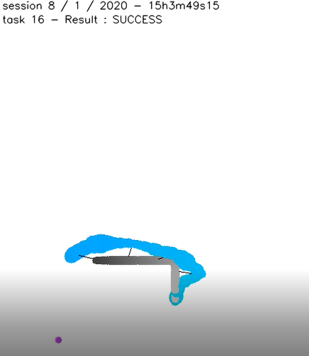

The overall result of the visualizations is the gradual improvement for the 3 subjects who experienced all the scenarios with Lola. For these children, the training is successful and the device appears to be a fun way of learning about joint action. It remains to be seen whether learning persists in the long term and is becoming more widespread in the actions of daily life requiring collaborative joint action, a capacity that is very rare in people with autism spectrum disorder.

# Références

Delaerche, E., Chetouani, M., Mahdhaoui, a., Saint-Georges, C., Viaux, S., & Cohen, D. (2012).I nterpersonal synchrony : a survey of evaluation methods across disciplines. *IEEE Transactions in affective computing.* DOI : 10.1109/I6AFFC.2012.12*.*

Fournier K. A., Hass C. J., Naik S. K., Lodha N.& Cauraugh J. H. (2010). ≪ Motor coordination in autism spectrum disorders : A synthesis and meta-analysis ≫. *Journal of Autism and Developmental Disorders*, *40*, 10, 1227–1240.

Kaur , M., Srinivasen, S., & Bhat, A.N. ( 2018) . Comparing motor performance, praxis, coordination and interpersonal synchrony between children with and without Autism Spectrum Disorder. *Research in Developmental Disabilities*, 72,79-95.

Grandin,T. (1995). *Penser en images*. Paris : Odile Jacob.

Nadel, J. (2015). *How imitation boots development in infancy and autism spectrum disorder.* Oxford, UK/ USA: Oxford University Press*.*

Raven, J. (1998). *Matrices Colorées de Raven.* Paris : ECPA.

Scharoun, S.M., & Bryden, P.J. (é016). Anticipatory planning in children with ASD : an assessment of independent and joint tasks. *Front. Integr.Neurosc ;*Doi.org/10.3389/fnint 2016.00029.

Zampella, C.J., Csumita, k.D., Simon, e., Bernetto, l. (2020). Interpersonal synchrony and its association with social and communication ability in children with and without autism Spectrum Disorder. *Jl of Autism and Developmental Disorders*, 50, 3195-3206.

# Appendix : Report to the parents of child 111 (we replaced the first name with X in the text).



**Motor collaboration training from November 2019 to January 2020**

**About X**

X, 7, has diligently trained on a virtual reality platform. The training consisted of 7 sessions for a set of 119 tasks. Each task consisted of moving a half-tangible and half-virtual object with a virtual partner.

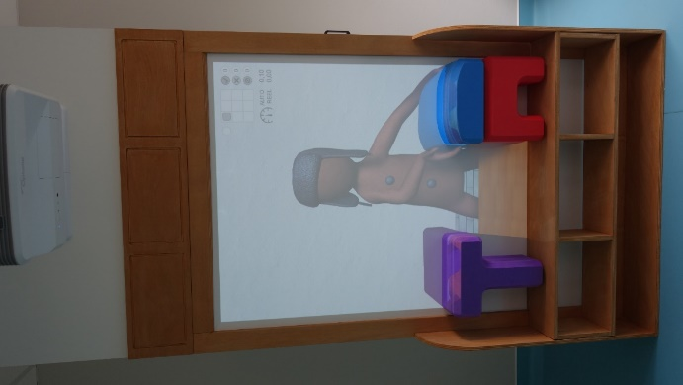

Figure 1-*The platform showing Lola ready to take*

*the box on the stool in order to place it on the table*

There were 3 phases in the training: 1) familiarization with the device and understanding of the procedure; 2) Training to move the object in accordance with Michou, the avatar who follows the child; 3) Training to follow Lola, the avatar who decides the direction and target of the move, as well as the speed. This phase tells us about the child's ability to adjust his rhythm to the rhythm of the partner, to understand the goal of the avatar by looking at his starting posture, the object he touches and his orientation towards the target. All these possibilities refer to the ability to take into account the movement of the other in one's own movements and to collaborate with the other concretely, a great social step.

Other elements revealed by the platform relate to the child's engagement, persistence despite failures, control of the speed and direction of movement, and the ability to attribute intentions to the virtual partner.

X proved to be very effective in this training. First he understood the purpose of the task right away and the familiarization was done in 2 tests. In the same session, we moved on to phase 2 of training, with Michou. It took three and a half sessions to pass to Lola because X had a hard time dragging the object: he often took it off from the virtual object which led him to failure. There was the perseverance of X, able to succeed a task after 30 failures without being discouraged, even if he said 'I have a bad heart' during repeated failures. It's a great quality that we would not necessarily have imagined at X, and that had to support our encouragement: *go Adam, you'll get there, you're almost there, it's very good.* It is emphasized that this child needs to gain confidence and feel that others trust him.

As the experiments with Lola progressed, improvements appeared. What was difficult for X was to follow Lola, not to be the one who decides where to go and especially how fast. This illustrates what we also see for language: a better ability to take (and keep) the word, than to respond by paying attention to what is said by the other. Despite this difficulty, X has come to a great success. Three figures illustrate the progress of movement and rhythm control to follow the virtual partner (moving from X to blue, moving the virtual partner in black).



Figure 2- *Management is respected but X*

*does not keep pace with Lola and is not accurate*

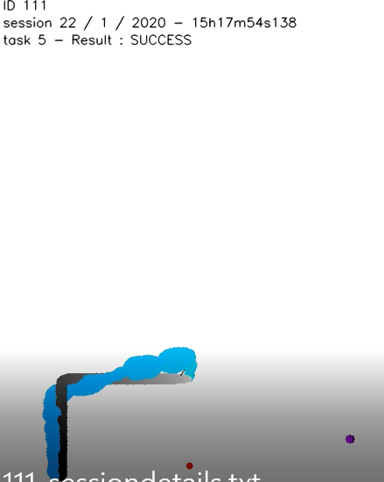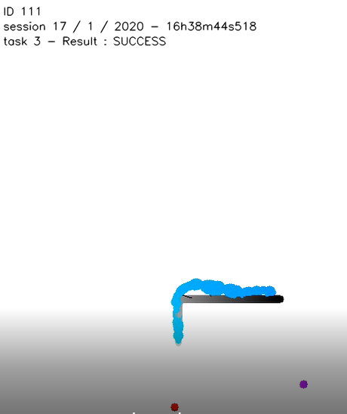

Figure 3 *-X manages to keep pace* Figure 4-  *At the last session,*  *X*

*of Lola on a short parcours*  *but he is* following *Lola* by *adopting his pace,*  *without the*

*imprecise ahead and with great precision*

X has clearly attributed intentions to virtual characters, saying that he prefers Michou because he is nice, he follows him. X is able to immediately recognize which object to take and in which direction to go by observing Lola's posture. He'd look for where Lola was, bypass the cabin and then ask to go inside to see. When the platform left for Germany, he asked for news of the characters and he is reassured to know that the platform will definitely return to Tedybear in early July.

Conclusion

X was awarded his Certificate of Excellence as a Small Investigator for helping us define the platform's best practice recommendations and for being among the best participants, demonstrating great qualities of perseverance, interest in competing with himself, good humour even in failure, and a quick and sustainable learning ability.

Jacqueline Nadel, Scientific Director of Tedybear

Paris, June 2, 2020

Family response

The father's response was very positive. They were very interested in the progression described and specially to see that their child was capable of perseverance in a playful activity where he was not judged by the avatar. They sent this report to the school attended by the child.