**Guide for Training Motor Collaboration**

Authors:

TEDyBEAR Center: Jacqueline NADEL

This project was carried out within the framework of the MIMETIC project.

"Software for training combined with collaborative social interaction and motor learning in Autism Spectrum Disorder".

This project is a winner of the Call for Autism and New Technologies projects, coordinated by FIRAH and supported by the Orange Foundation and the UEFA Children's Foundation.

Work done by:

 

TEDyBEAR and LIMSI-CNRS

The project was supported by: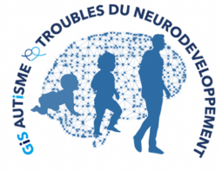



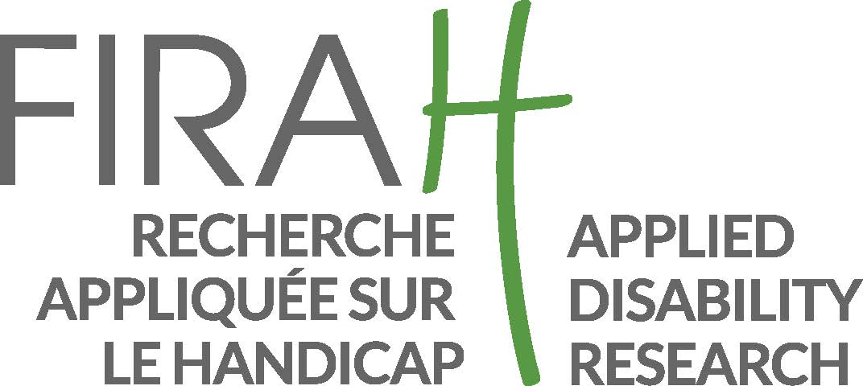

Web sites:

<https://mimetic.limsi.fr/>

<https://www.firah.org/fr/logiciel-pour-l-entrainement-combine-a-l-interaction-sociale-cooperative-et-a-l-apprentissage-moteur.html>



The FIRAH is a Foundation recognized as a public utility, which wishes to put research at the service of actors in the field. It is chaired by Patrick Gohet.

It is to meet the needs and expectations of people with disabilities that FIRAH was founded and that it develops today around these activities:

* Support applied research projects on disability.
* To stimulate the valorization of the results of this research in particular with the actors in the field.
* Animate the dissemination of knowledge on disability produced throughout the world.

<http://www.firah.org>

Tedybear 

Tedybear is a group of experimental medical-social centers dedicated to the education of young children with Autism Spectrum Disorder (ASD) between the ages of 3 and 11, most of whom are non-verbal. These centers are approved by the ARS d'Ile de France. One is located in Saint-Cloud, the other more recent one is in Paris. TEDyBEAR has developed an innovative pedagogical concept based on inclusive education and coordination with family and caregivers.

With the objective of school inclusion: Sharing of time between the school and the center; Coordination with the school: participation in the ESS, GEVASCO, implementation of liaison notebooks, visits to the center by teachers and AVS, and by liberal therapists (speech therapist, psychomotricist, occupational therapist).

In the objective of coordination with the family: Educational booklet given out each weekend with weekly sheet from the referring psychologist, monthly curves of positive and negative behaviors; weekly sheet from the educators providing information on autonomy and social adaptation to peers; daily relay table to the families showing clips of the day; In return, weekly sheet filled out by the parents and providing information on behavior at home during the week.

Tedybear works in 1/2/3: one child for a psychologist during the therapies, 2 children for a psychologist for the pedagogical activities, 3 children for an educator for the activities relaying with the school in the field of socialization.

The pedagogical work is of the neuro-educational type with the social brain exercise as a base. A particular focus is placed on imitation, which is central to development in that it is closely related to major functions, perception, action, language, and is the initial support for communication and learning. Therapies are of two types: imitation to develop non-verbal communication and observational learning, and kinect to develop body awareness and calibration of spatial organization.



LIMSI-CNRS (www.limsi.fr, BP 133, 91403 Orsay).

The Laboratory of Computer Science for Mechanics and Engineering Sciences is a multidisciplinary research laboratory that brings together researchers from different disciplines of Engineering and Information Sciences as well as Life Sciences and Social and Human Sciences. Administratively, the LIMSI is a CNRS unit, attached to the Institute of Information Sciences and their Interactions of the CNRS.

Research in human-computer interaction is interested on the one hand in analyzing, understanding and modeling the interactions between humans and artificial systems. The CPU group involved in this project focuses on the psychology of non-verbal and collective affective interactions in humans as well as on the design of affective and virtual human-computer interfaces. The members of the group are teacher-researchers from the University Paris-Saclay in Computer Science, Human-Computer Interaction and Psychology.

Several projects concern the training of social skills for (children, adolescents and adults; with or without pathology) such as the design of virtual characters for training job interviews or training of health care staff using virtual patients. Researchers participate in the definition of theoretical frameworks, the design of human-computer interactions and their experimental evaluation.

**Outline**

PLATFORM OBJECTIVE 5

Do our children contribute to actions together? 5

Why not? 6

ADAPT THE PROTOCOL TO EACH CHILD'S SPECIFICITIES 6

1. Familiarization phase with the platform 7

2. Training phase to adjust the real object to the virtual object with Michou 8

3. Training phase to follow Lola, the autonomous avatar 12

CONCLUSION 15

# PLATFORM OBJECTIVE

Collaborative motor actions are the actions that are done together such as carrying together a basket too heavy to carry it alone, or moving together a piece of furniture by rotating it to pass a door. With these actions, the most difficult thing is to coordinate with the other: lacing your shoes together is more difficult than lacing them alone. Yet in both cases motor coordination is required. But on your own you have your own rhythm to adjust the movement from one hand to the other, while you have to adjust to the rhythm of the other and to their posture to lift something at the same time.

## Do our children contribute to actions together?

Doing collaborative action is helping to do something physical by coordinating with the other. This is not to clear your plate after dinner, or open the garage door. In these cases, we help, but with our own movements. There is no need to coordinate with others. To do a collaborative motor action is to do something together. Does your child help you like this? Is s/he carrying with you a heavy basket, each with a handle, on their way back from the market? Do they help you place a large box in the car? Do they help you move a piece of furniture?

The answers to the questionnaires I sent to the parents of our children with severe and non-verbal ASD are clear: **no!** Their children do not help spontaneously, and parents do not ask them to do so. Why would you do that? Parents say they would not be able to do it or that it would take longer than doing it themselves.

## Why not?

What explanations can be given to this? That our children are not great communicators? That they don't care much about others? That they have a hard time understanding other people's intentions? That they don't respond to requests? All of this is true. But there is something more crucial: they have big problems with motor coordination. Research published a few years ago in a specialized scientific journal *(Journal of Autism and Developmental Disorders)* compared more than 1000 people with ASD of all ages and levels to 3,000 typical people comparable in age and level. This research shows that motor coordination difficulties are a cardinal symptom of autism as they affect the entire autistic population (Fournier et al., 2010).

Obviously, those who already have trouble coordinating one hand with the other are even more in trouble if you have to consider the movement of the other, his speed, his posture, anticipate the rest of the action and how the other will position himself to do so.

The goal of the virtual platform is to learn in a playful way to position yourself properly in relation to a small avatar to move an object together. The object has 2 parts, a real part carried by the child and a virtual part carried by the small avatar. The two parts of the object must not come off, and for this you have to coordinate with the avatar.

# ADAPT THE PROTOCOL TO EACH CHILD'S SPECIFICITIES

How are we going to get the child to practice with the avatar? We distinguish three key moments to adapt the protocol to the specifics of the children:

-a phase of familiarization with the platform

-a learning phase of coordination with the avatar that follows the child

-a phase of adaptation to the speed, the path and the direction of the avatar that the child must follow.

### 1. Familiarization phase with the platform

We must pay close attention to this phase because it will condition the rest for some children, those who are rigid and have difficulty accepting change. Indeed, there is a significant change in a room that was reserved for another use: now there is a platform in it.

If the child understands the language, we can explain to him that we have installed a game and that he can go and see this game if he wants. It may take several attempts before he/she agrees to enter the transformed room. We can start by leaving the door open: he/she will eventually take a look inside. Another time, the platform will be lit with the Avatar Michou, the one that follows, ready to follow you. We can tell the child that Michou is waiting for her/him and ask her/him ifs/ he wants to play with him.

If the child is non-verbal, a photo of the platform in the room will be prepared on a tablet, the photo will be shown to the child and the room will be shown with an open door. Another time, as before, the platform will be lit and actioned with Michou, and then the child will be left with it if he wants. We will not insist. It is better to wait and that the places and the platform are well accepted, this is the guarantee of success of the training. If the child refuses or shows discomfort, it is best to give up training for that child. He may accept later when he sees others come to this room with pleasure and use the platform: remote observation often helps to remove fears and resistances.

For other children, this phase is not necessary. They willingly enter the room and want to participate immediately. In our experience, this is more the case for children who are a bit verbal. For non-verbal children, we encountered difficulties that made us think about how to prepare these children to accept the platform.

First of all, we can try to offer on tablet a filmed simulation of the procedure. The procedure would be divided into steps separated by a white period of 10 seconds. We had considered this device but ruled it out because of the difficulty for some children to spot the similarity between the 2-dimensional visualized device and the actual device. Another proposal is to first have the real objects worn to familiarize the child with the movement of the object. However, as we have seen, this prerequisite can turn to disadvantage because the child does not learn the need to adhere the tangible object to the wall and match it to the virtual object. On the contrary, it is confirmed in the intuitive gesture to take the object.

In the face of the failure of the situation for children with very low functioning abilities, we believe it is important to treat the familiarization stage in a completely individual way. Thus une verbal child of our population had a violent crisis by noting that the real object can remain suspended from the wall by adhesion: the physical causality that makes it clear that objects fall if they are not held was questioned and provoked a reaction of panic fear that we had not anticipated.

### 2. Training phase to adjust the real object to the virtual object with Michou

Once the child has agreed to enter the room, look at the screen and the little avatar that is on it, one can move on to the training phase. The child must understand that he must grasp the real object but not detach it from the partition that serves as a screen. This is the first difficulty because spontaneously the child tends to take the object. If he takes it, he detaches it from the partition and no action with Michou can be realized since the virtual object and the real object are no longer in contact. Whether the children are verbal or not, a good way to start is to make a direct demonstration: *"You see, you have to drag the box and Michou drags it too. We can put the box on the stool, or on the table or on the floor. Now she's on the stool, we're going to try to put her on the table by dragging* her." For non-verbal children, one can mimic useful gestures several times and show that when one takes the object, Michou drops his own.

Some children understand very quickly but for others it is very difficult to control themselves so as not to take the object into their own hands. Failures can last a very long time or even reappear at the beginning of the next session when the child understood: it's so intuitive to take the object and move it from one point to another! In this situation, your presence and encouragement are essential: *'Yes! it's almost good, you'll get there! let's do it again! come on, let's do it again!* '

This phase can last a very long time and the child should not be discouraged. It's up to you to make your enthusiasm communicative.

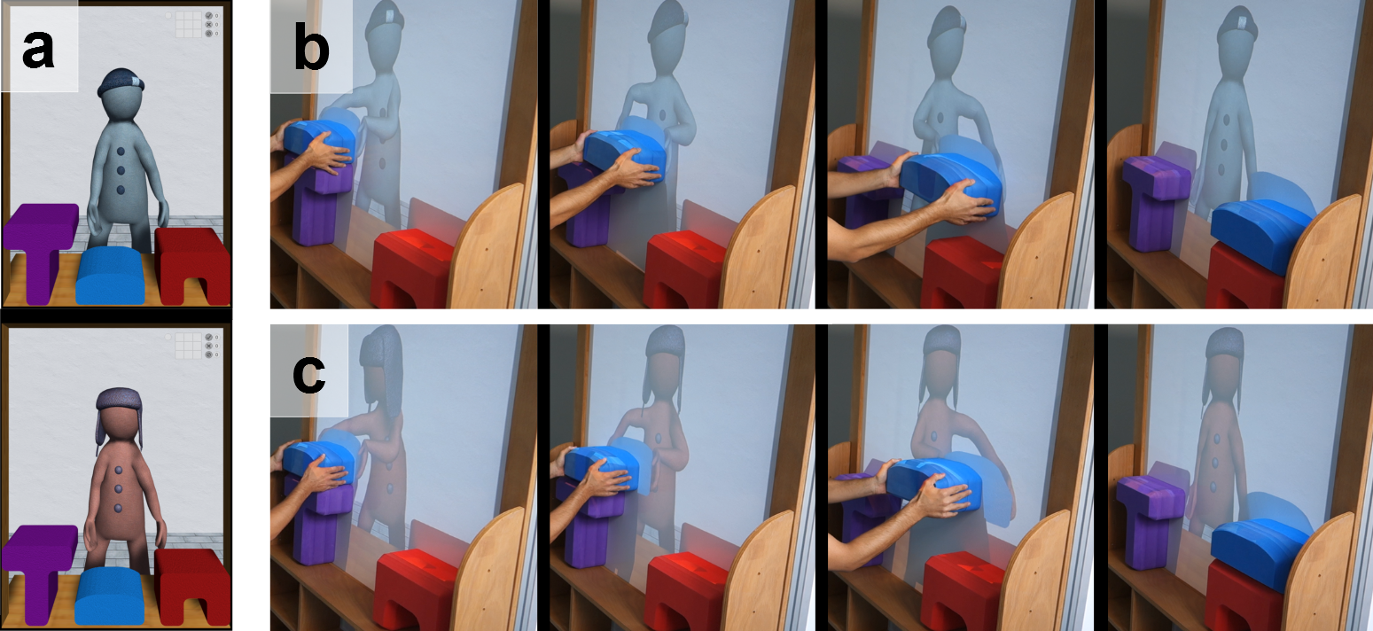

*Figure 1. In a, we see Michou waiting in the top image, Lola is at the bottom. In b, we see Michou positioning himself in relation to the blue box, where the subject put his hands, and then follow with the virtual box (in lighter blue) the path taken by the subject until the arrival on the red stool. In c, we see Lola autonomously deciding a similar trajectory and the subject following her.*

Added to this difficulty is the need to fight gravity by dragging a magnetized object that resists thrust (this is what gives the impression that it is heavy). When it is necessary to move the object by raising it, the work against gravity is at its peak. When it is necessary to move the object down, another difficulty appears, it is necessary to slow down its gesture, otherwise the object will fall, always because of the gravity. It is therefore necessary to control its strength and stabilize its hypertonic movement, which explains many failures..

A second difficulty is to control throughout the scenario that the adhesion between the real object and the virtual object is maintained. This means that you have to both keep dragging the object and remember the purpose (for example, putting the stool next to the table). Keep in mind that the stool is drooped so that it is next to the table or that the box is dragging **to**  the table. You can help him by calling him the goal: 'We *go to the table, continue, we didn’t arrive'.* This aspect of training can be used as therapy in all cases where the child quickly loses the objective of his actions. However, as we know, the ability to maintain an objective is often lacking in autism spectrum disorder.

A third difficulty of the collaboration task is that the child must perform 4 scenarios representing 4 different routes: hoisting the floor box on the table; sliding the stool next to the table; Take the box on the table and place it on the stool; take the box on the stool and place it on the floor. The instruction is verbal for children with a small language, and modeled by directly showing the action to be performed for non-verbal children. It is therefore necessary for children to understand and follow the instructions. It is about being able to inhibit your internal motivation in order to carry out the action requested. This ability to control one’s motivations is often very low in our children. The device therefore offers the possibility of causing these executive difficulties in a playful way.

Languagehas an effect on familiarization since 6/7 of children with verbal comprehension switch to the Lola task after a single workout with Michou, while most non-verbal children remain on familiarization or training with Michou, despite the fact that the procedure is mimicked many times live. One of our slightly language children stays on training with Michou for the 7 sessions he has enjoyed. His behavior is interesting to describe because from his first confrontation with the platform, he is interested in the virtual agent and sings: "Head, shoulder, hands, feet", touching Michou. He touches and caresses him many times and this will be true during the following sessions. So, he is a contact for him, but on the other hand the task is subordinate, and he did not understand the role of the object in collaboration. collaboration.

Other aspects of the scheme can disrupt higher-level children and cause them to lose their original purpose by deviating to interfering interests. Temple Grandin has clearly identified how a sensation during an action can change the current goal (Grandin, 1995). So, three of our language-based children focused on indicating successes and failures, counting scores. One of these only looked at this counter, neglecting the avatar and objects to change places. Another caused scores by trying various behaviors unsuited to the task but adapted to make the meter work. Finally, for a third child of good level, the performance decreased continuously because he was only looking for the rewards stars and did not pay attention to the avatar.

The training phase with Michou is effective if all four scenarios are successful: dragging the real object along the partition instead of taking it, ensuring that the virtual object adheres to the real object, maintaining grip throughout the course and not giving priority to one’s own motivation by making personal paths that do not follow the instruction.

### 3. Training phase to follow Lola, the autonomous avatar

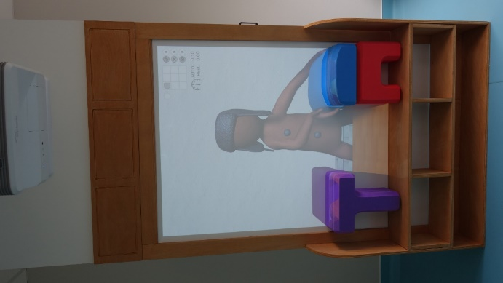Once the child has completed training with Michou, he is introduced to Lola. Lola is distinguished from Michou by her hat that resembles long hair (see Figure 1a, bottom image) and by her behavior. Lola has human postures: she waits, arms dangling, when the child has dropped the object. By her gesture, she indicates which object she will move. She turns her head to where she will place the object. Indeed, it is not like Michou who follows, it is she who decides what object to take, where to go and how fast. The child no longer has a protocol to follow like *'you're going to put the box that's on the stool', they* just have to follow Lola. And it's much more difficult. Why is it harder?

*Figure 2- Lola is ready to rise the box and gazes at the table where she intends to drop the box.*

First of all, you have to understand what object Lola chose to take. She has her hands on it so it's not the most complicated, but you have to imitate her choice and grasp the same object. You will see some children in difficulty because they preferred to take another object. You may have to have them try several times so that they understand that in this case obviously the action cannot be performed. This is an opportunity to learn the limit of your good will. Again, it will take skill not to discourage the child. Some say on this occasion that they prefer Michou: obviously with Michou we do what we want.

Lola she is turned to where she is going to go: she points in a direction. It is very interesting to note that very quickly the children spot his posture as a kind of pointing (see Figure 2). This can move them towards understanding joint attention. It is up to you to take this information into account to advance them, so that they learn that the posture and orientation of the head indicate a goal: it is a good playful opportunity to do so.

Finally, Lola starts and you have to keep her real object adjusted to the virtual object she moves at the speed she has chosen. Now things are getting tougher. Indeed, Lola's speed can be very difficult to follow. We will detail these points.

***Follow Lola in optimal speed***

The optimum speed is the speed the child had when he was exercising with Michou. With Michou he was taking the speed he wanted. It is this speed that Lola chooses in the first session. In summary, the child must take the object that Lola took in virtual, he must prepare to go in the direction that Lola's posture indicates, and he must follow the speed of Lola which is his favorite speed. The biggest difficulty and the only one is to understand that it is Lola who decides and that one can neither choose the object, nor where to go to put it.

***Follow Lola in fast speed***

The fast speed is chosen by the adult who controls the experience with the small case. It must be sufficiently different from the optimum speed for the child to feel it and be forced to hurry. Going fast and keeping the object in contact with the virtual object requires a lot of attention paid to moving the virtual object. In the paths from the automatic analysis of movements, we see oscillations that show that contact with the virtual object escapes a little at times and that the child catches up with it (see Figure 3).

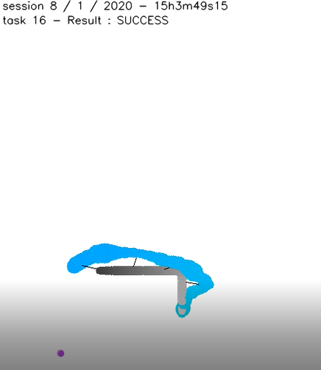

*Figure 3 - In black, Lola's path, in blue that of*

*the child who sometimes strays and then returns*

***Follow Lola in slow speed***

The slow speed is chosen based on the child's optimum speed so that he or she clearly feels the need to slow down. This is the most difficult synchrony to achieve. Indeed, slowness multiplies the problems of resistance to gravity. The slower the box is to be raised, the longer and more persistent the effort. To achieve this, you have to bow, tense your body, spread your legs to find a better balance, sometimes even kneeling. This is a very rich moment of observation of the child's overall motor skills. Each child will do it differently. It's up to you to guide him to find the right way to succeed: 'You *can spread your legs; you can get down on your knees, it'll be easier.'* You can mimic, but never forget that everyone has their own technique of balance and motor skills. There is no point in wanting the child to do exactly as you do because he does not have the same body, the same tone, the same ability to resist. So 'look *how I do'* is not the best formula unless you propose several postures between which the child will be able to find the one that suits him.

Going down an object very slowly is no easier. Here we have to break even more than for other speeds, while gravity drives us to go fast or even to drop the object. Control of its movement is crucial. You will be able to take information again about the child's motor coordination abilities.

# CONCLUSION

There are many questions about this training. For example, at what rate do the exercises? We found that close trials were most likely to cause rapid progress. This is not surprising since there is a lot of motor adjustment in this task, and all motor skills are best exercised regularly. Training once a week is really too little, one workout a day is ideal, and you can find a good balance every other day.

Another question is: outside the platform, how can we ensure that they are extended into everyday life, and practice our children to collaborate? We present a library of motor actions that illustrates the scenarios of the virtual platform and their equivalent between two humans. All it takes is a large box, a table and a stool to check whether the child trained on the platform has learned to follow the speed of the other, to follow the direction of the other, to adjust his movement to the movement of the other. Do it and you'll see.

Finally, a big question, a big question comes to mind. From 3 objects, a table, a stool and a box (see Figure 4), simple scenarios are drawn up so that they are accessible to all. The goal is for the child to adapt his motor skills to a social goal: to collaborate with the other.

Does the task of getting a virtual object to adhere to a real object allow us to achieve the goal of training to do two-way actions, to carry out motor collaborations?



*Figure 4- The table, stool and box*

You'd doubt it. One might think that the child is just learning to stick both parts of an object regardless of the speed imposed by the virtual object. It would be to forget a very strong element in our scenarios: the presence of our little avatars. Immediately they are known by their first name and differentiated. Non-verbal children do not name them but are able to show who Michou is and who Lola is. They can address them like the little one who sings 'head, shoulder, hands, feet', touching the corresponding parts of Michou's body. They can involve him as the child who says *'Come on Lola, let’s go*!'. They can attribute intentions to him: *"Lola makes me miss!"* And above all, it is not the least interest of this platform to see them get down on their stomachs under the cabin, or try to get behind, or try to open the cabin door in search of Michou and Lola. Behind the adhesion between the real object and the virtual object, there is indeed a small partner with whom one carries the object. The personification is so strong that when the platform left for a while in Germany, the children asked where Michou and Lola were.

It is not the least interest of this platform to see non-verbal children flattening themselves on the ground to look under the platform, visibly looking for where the avatars are. They too are capable of anthropomorphism, i.e., to attribute to these little characters the intentions of humans. We might not have discovered it without their behavior in front of the virtual platform, as it is difficult for us to conceive a thought without language.