**Requirement Analysis:   
Study and analysis of the needs of collaborative motor actions in family, professional/employment and educational environments**

Author:

TEDyBEAR: Jacqueline NADEL

This project was carried out within the framework of the MIMETIC project.

"Software for training combined with collaborative social interaction and motor learning in Autism Spectrum Disorder".

This project is a winner of the Call for Autism and New Technologies projects, coordinated by FIRAH and supported by the Orange Foundation and the UEFA Children's Foundation.

Work done by:

 

TEDyBEAR and LIMSI-CNRS

The project was supported by: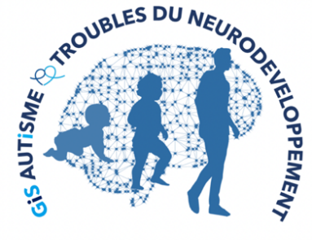

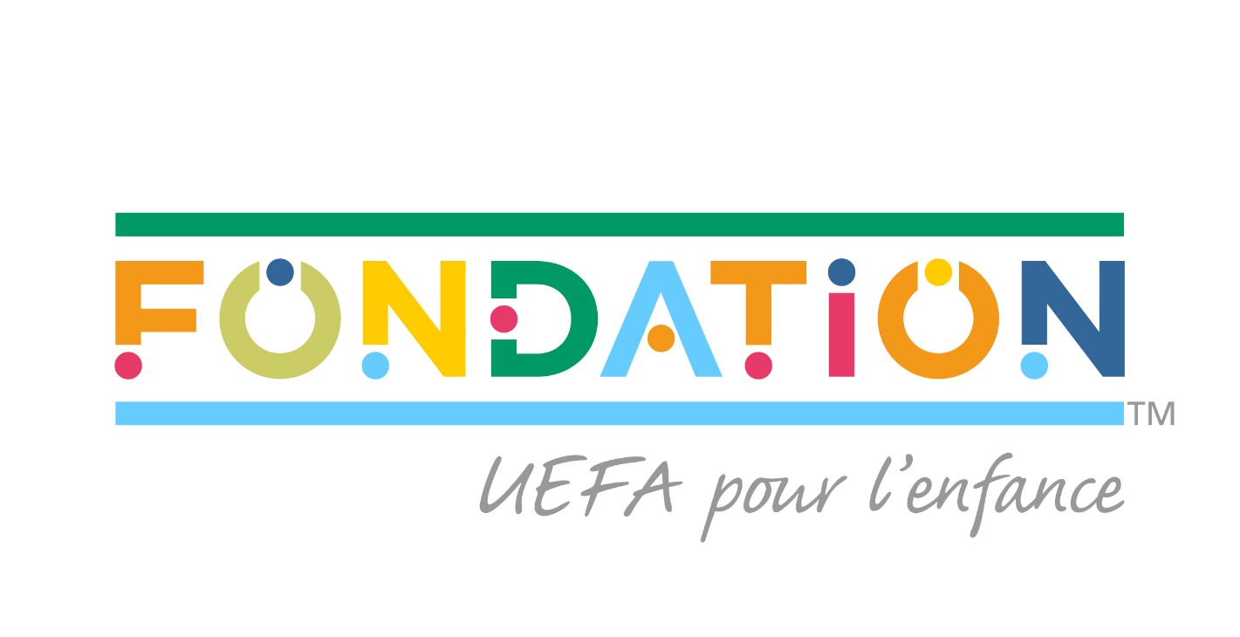

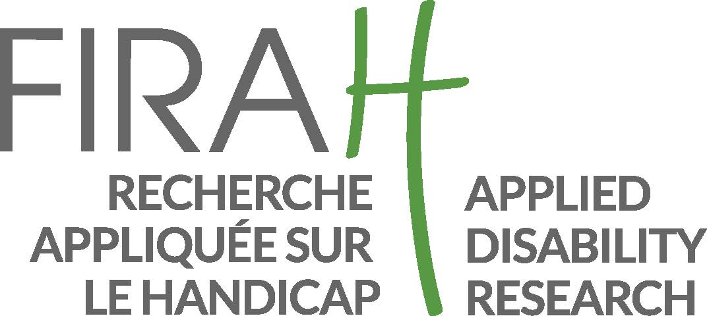

Web sites:

<https://mimetic.limsi.fr/>

<https://www.firah.org/fr/logiciel-pour-l-entrainement-combine-a-l-interaction-sociale-cooperative-et-a-l-apprentissage-moteur.html>



The mission of the International Foundation for Applied Research on Disability (FIRAH, **[http://www.firah.org/)](http://www.firah.org/" \o "Site internet de la FIRAH, nouvelle fenêtre)** revolves around 2 complementary and interrelated axes:

1/ The selection and funding of applied research projects on disability through its annual calls for projects,

2/ The coordination of the Applied Research and Disability Resource Center. The Resource Center is a collaborative space for knowledge sharing concerning applied research on disability. It wishes to put research on disability at the service of field actors[1] by taking into account their needs and expectations by facilitating the setting up of applied research projects, disseminating and promoting their results.



**[http://www.firah.org/centre-ressources/](http://www.firah.org/centre-ressources/" \o "Site internet du Centre Ressources Recherche Appliquée et Handicap, nouvelle fenêtre)**

Tedybear 

Tedybear is a group of experimental medical-social centers dedicated to the education of young children with Autism Spectrum Disorder (ASD) between the ages of 3 and 11, most of whom are non-verbal. These centers are approved by the ARS d'Ile de France. One is located in Saint-Cloud, the other more recent one is in Paris.

TEDyBEAR has developed an innovative pedagogical concept based on inclusive education and coordination with family and caregivers.

With the goal of inclusive education:

* Sharing of time between the school and the center
* Coordination with the school: participation in the ESS, GEVASCO, setting up liaison notebooks, visits to the center by teachers and AVS, and by liberal therapists (speech therapist, psychomotricist, occupational therapist).

In order to coordinate with the family

* Teaching notebook handed out every weekend with the referent psychologist's weekly sheet, monthly curves of positive and negative behaviors,
* Weekly educators' sheet providing information on self-sufficiency and social adaptation to peers; daily relay tablet to families showing clips from the day.
* In return, a weekly form filled out by the parents and providing information on behaviour at home during the week.

Tedybear works in 1/2/3: one child for a psychologist during the therapies, 2 children for a psychologist for the pedagogical activities, 3 children for an educator for the activities relaying with the school in the field of socialization.

The pedagogical work is of the neuro-educational type with the social brain exercise as a base. A particular focus is placed on imitation, which is central to development in that it is closely related to major functions, perception, action, language, and is the initial support for communication and learning.

Therapies are of two types: imitation to develop non-verbal communication and observational learning, and kinect to develop body awareness and calibration of spatial organization.



LIMSI-CNRS (www.limsi.fr, BP 133, 91403 Orsay).

The Laboratory of Computer Science for Mechanics and Engineering Sciences is a multidisciplinary research laboratory that brings together researchers from different disciplines of Engineering and Information Sciences as well as Life Sciences and Social and Human Sciences. Administratively, the LIMSI is a CNRS unit, attached to the Institute of Information Sciences and their Interactions of the CNRS.

Research in human-computer interaction is interested on the one hand in analyzing, understanding and modeling the interactions between humans and artificial systems. The CPU group involved in this project focuses on the psychology of non-verbal and collective affective interactions in humans as well as on the design of affective and virtual human-computer interfaces. The members of the group are teacher-researchers from the University Paris-Saclay in Computer Science, Human-Computer Interaction and Psychology.

Several projects concern the training of social skills for (children, adolescents and adults; with or without pathology) such as the design of virtual characters for training job interviews or training of health care staff using virtual patients. Researchers participate in the definition of theoretical frameworks, the design of human-computer interactions and their experimental evaluation.

**Summary**

I. Who are the beneficiaries? 5

II. What: What are the needs of the beneficiaries, for what purpose and for what reason? 6

III. Conclusion of the survey: an answer to the question why and why not? 14

IV. How? 15

This project aims to design a software and hardware system for training combined with collaborative social interaction and motor learning by enabling collaborative actions (Figure 1).



**Figure 1 - Examples of social interaction based on motor collaboration: sawing, lifting a heavy object, etc.**

The needs analysis described in this document is intended to answer the three fundamental questions that will determine the organization and execution of our project.

These three questions concern the ***Who?*** (designating the beneficiaries), the ***What?*** (characterizing the objectives and their rationale) and the ***How?*** (defining the means of the objectives).

## Who are the beneficiaries?

The beneficiaries are first and foremost the individuals who will use *the software for collaborative social interaction and motor learning training in Autism Spectrum Disorder (ASD).* The software is intended for people with ASD, primarily children, but also adolescents. We must therefore diversify our needs analyses according to age. Likewise, we must take into account the heterogeneity of the autism spectrum, knowing that some of these individuals are verbal, of average or even higher than typical cognitive potential for certain skills, while others are non-verbal and of very modest cognitive potential, especially when an intellectual disability is associated with autism. All the intermediaries between these two extremes are found. We are particularly focused on severe communication deficits in the case of non-verbal individuals. Indeed, the role of gross motor skills in enabling social interactions is even more important in these cases than for verbal persons. However, difficulties in motor coordination and postural balance are reported as specific to the population with ASDs and can affect verbal individuals just as much, as shown in our review of the literature.

In addition to the direct users of the software, the family of these children should also benefit: indeed, the software is designed to train the child to physically collaborate with others in motor tasks and therefore, if the training is effective, the child should be able to help in daily life and take into account the movements and gestures of others, which could greatly improve the well-being of the whole family.

In addition, the development of collaborative motor skills could be taken into account by professionals to improve the inclusion of children in group activities, especially sports. Finally, in the case where training with the software would, as we hope, bring a notable improvement in social motor skills, i.e. motor skills in dialogue with the motor skills of others, it is the community of professionals and caregivers who would benefit from an advance in knowledge: improving motor collaboration with others to improve communication would become a method for non-verbal children. Thus, to the question of who the beneficiaries are, we will answer: children and adolescents as direct users, but also families, caregivers and professionals, beneficiaries of the effects of the training on the users' behavior and on the knowledge concerning the bases of communication development.

## What: What are the needs of the beneficiaries, for what purpose and for what reason?

This question responds to two aspects that it is useful to differentiate: on the one hand the **why, i.e. the** ultimate goal of using the tool, and on the other hand the **why that** formalizes the cause of the need.

This needs analysis phase is a phase of communication and exchange with future users, in this case people with ASDs (when they can analyze their needs), and the indirect beneficiaries that are parents, caregivers, and professionals.

To carry out this phase, it is necessary to listen to the future beneficiaries, parents and professionals.

1. **The parents**

The ideal setting is that of individual interviews, and we conducted 20 such interviews with the parents during the PPI (Personalized Individual Project) of their non-verbal child. Another framework, which is less effective but allows us to reach a larger population, is the questionnaire framework. The wording of the questionnaire used with 20 other parents is presented in Table 1.

Table 1- Questionnaire for parents

**Dear parents, can you answer the following questions for us**

**allow to work on the project concerning the collective activities of the children?**

|  |
| --- |
| ° Does your child help you? Yes No |
| * You have to ask him or he does it on his own? * Can you tell what it can help: for example, carrying something heavy or bulky with you, or taking one end of the tablecloth and you take the other for folding, etc.? |
|  |
| ° Does your child participate in group activities? Yes No   * Which ones? |
|  |
| °What would he be able to do collectively if he wanted to? |
| * Would he do it well? |
| * If not, why not? |
| Does he play a team sport? Yes No   * If so, which one? |
|  |
| Does he participate in group activities at school? Yes No   * If so, which ones? |
|  |
| What kind of game can we play with him? |
| And the other children, what can they do with him? |

Parents' responses were divided into two groups: 12 out of 20 answered 'no' to all the questions about collaborative activities, and the remaining 8 answered 'yes', but with wide disparities in assessment.

1. **Negative responses to motor aid**

With regard to the 12 negative responses, the parents' explanations for the child's lack of help were as follows: 'he is not agile with his hands'; 'he doesn't have much balance'; 'his arms are weak, he drops things'; 'he breaks everything'. These responses therefore bring to the forefront the motor difficulties and postural balance necessary for motor collaboration. But there are other answers such as: 'he doesn't understand what it means to help' or 'we don't have the idea of asking him'.

Interviews reveal the same high percentage of negative responses to help. Everything concerning autonomy is impacted by this phenomenon: even raising the arms to make it easier to put on the sweater, or stretching out the foot to help put on the shoe is done on demand and is not produced spontaneously. This emphasizes the difficulties of these children in conceiving the motor stages of an action and in anticipating the movement necessary to perform all or part of the action.

When seeking clarification on what hinders collaborative action, parents often admit their resignation when faced with the problems of motor collaboration with their child: 'it would take time and patience'; 'we prefer to do things ourselves, it goes faster'. They thus express in a very obvious way the question of the rhythm of family life, and the fact that the child is out of step with this rhythm: the time of his motor skills is not the time of his entourage. As a result, the synchronization of actions is very difficult. Some answers relate to the sensory profile of the child: he does not like to touch the tissues', or his sensitivity to failure: 'if he does not succeed immediately, he has a seizure'.

Some responses are very significant of the motor difficulties anticipated by the parents. To the question: what would he be able to do in a group if he wanted to, one answer is: "to cook with me, to cut vegetables, to stir the pot". But to the next question: Would he do it well, the answer is 'no'.

**In summary**, **synchronizing on the movements of the other is a behavior that is felt in everyday life to be very difficult to achieve, and the discrepancy between the child's rhythm and that of the family is a very big burden for families. This is why, for most parents, improving autonomy is a priority and outweighs all other needs**.

1. **Positive responses to motor assistance**

By combining the responses to the questionnaires and interviews, i.e. 40 responses, the 42% of parents (N=17) who answered positively to the question of whether the child helps them can be divided into two subgroups: those, the most numerous, who answer that the child helps them only on request, and those, the fewest (4/17) who answer that sometimes the child can help them spontaneously.

Interestingly enough, in all spontaneous cases it is a tidying-up aid: picking up, putting back in place, which corresponds to the autistic specificities of intolerance to change. One of the children is doing judo with ordinary children, accompanied by an animator, without knowing exactly what kind of movements referred to the movements of the other he is able to control. A parent points out that his child can give his sister a hand: this is a very basic motor collaboration, but it is indeed one.

For those who help on demand, the aids brought back concern the kitchen, where the child can mix, pour into a dish held by the other, sweep in a shovel held by the adult. A child opens the garage door but the activity, although cooperative, is based on the child's motor skills alone. Similarly, parents often report that the child can help clear the table and take his or her plate to the kitchen after the meal, but these are cooperative activities that do not require adapting to the movement of the other, so we will not hold them back.

**In summary, when there is help, it is concentrated on tidying activities or cooking activities where the motor collaboration is based on the adult supporting the child's behaviour: the collaboration is asymmetrical, the adult acts in a way that allows the child to carry out his or her part of the collaborative action.**

1. **High level parent and adult associations**

The parents' associations of Autisme-France, Sésame-Autisme, UNAPEI, Dialogue-Autisme were consulted in the person of their presidents. Similarly, three high-level adults were consulted. Below (see Table 2) is the letter that was sent to them individually. One of the persons with TSA forwarded it to his network with my agreement.

Table 2- Letter addressed to associations of parents and high level adults with ASDs

Paris, March 7, 2018

Dear colleagues and friends

The FIRAH and Orange-mécénat autisme have selected us for the realization of an applied research program within the framework of a call for digital projects.

Our goal is to develop collaborative motor skills in young people with ASD by training them to perform simple tasks that require them to take into account each other's movement, posture and motor skills (carrying a heavy bag in pairs, moving a table in pairs, passing a large box through a door, etc.). Our idea is that taking into account the other's movement is already taking the other into account, that a motor dialogue introduces to social interaction and communication. We will therefore train the children first with a virtual partner and then with another child on tasks validated by families, caregivers, experts. It is an approach centered on the user (in this case people with ASD), families and caregivers.

After having gathered the bibliography (which is not abundant), we now need to conduct a needs and feasibility study with families, professionals, people with ASD and experts from associations.

For this I ask for your help. I asked the parents of our Tedybear center to answer a questionnaire in which we wanted to know their expectations regarding their child's collaboration in family life. Reading the answers, it appears that the parents only have expectations related to what they think is currently possible for their child: very realistic and generous, they don't think about them and what they would like, just about what the child actually does. So I don't have an overview of the needs of families in terms of their child's collaboration in the daily life of the home.

Could you enlighten me on the following point: what expectations, what needs could our parents of non-verbal children aged 4 to 8 legitimately have in terms of collaboration at work at home and physical exercise in pairs or groups? The purpose of this question is to diversify the tasks that we will propose and to be assured that these tasks represent a concrete response to the general needs of families.

A second point would be to tell me what collaborative activities seem to you to be contraindicated given the specificities of ASD. The purpose of this question is to assess the feasibility of the tasks we are going to build.

Once the tasks have been finalized at the computer level, we would be happy if you could give your opinion on the realism of the avatars' postures and movements, and on the relevance of the device for our population with ASD, before the experimental phase.

I have no doubt that you will answer me. Please do so with as much detail as possible, if you don't mind. It is a great help that you will bring us this way.

Best regards to all of you,

Jacqueline Nadel , Director of Research and Innovations, Tedybear Centers

Association presidents respond by referring to their personal experience and selecting what is generalizable. The result is a list of possible collaborative tasks.

- ***Giving a hand*** is one of the only collaborative tasks that can be done with children with severe motor deficits, and it can be complicated.

-***Participate in small gardening tasks with the help of the adult***: but this is more of an adult's help to the child's activity than a collaborative task.

-***Tandem riding*** can be collaborative as long as the child's pedaling is synchronized with the pedaling of the other, but the child can also be passive and be taken for a ride, which then excludes collaboration.

-***Make a recipe by mixing the ingredients one at a time*** (but this is an alternating activity, not a collaborative activity)

***-Sweeping: one holds the broom, the other puts the shovel in the right place to collect the dust.***

***-Playing table soccer***

-***Games of marbles***: one sends, the other recovers and can position itself with a basket.

**Summary: The low response rate and the difficulty in providing examples of collaborative motor skills support the fact, already noted in the direct survey of parents, that parents have difficulty conceiving of the possibility of motor activities involving bodily dialogue between them and their child. They talk more easily about difficulties in verbal or emotional communication than about motor-related aspects. If they talk about motor skills or balance, it is to evoke the aspects of solitary achievement (cf. 'she climbs the doors by the hinges to position herself as a bird above and swing the door'). Motor collaboration as a social form of interaction remains today a poorly defined field that lacks fine and precise observations. For us, this is an encouragement to develop it.**

**Some interesting suggestions, in addition to those already indicated by the parents, such as giving a hand and organizing the shovel in relation to the broom, or playing tandem or table soccer.**

1. **Professionals, psychologists, psychomotor therapists and educators**

These indirect beneficiaries received the same letter as the associations and individuals with high potential with ASD. The letter does not compel responses and yet the responses are fairly consensual.

Our professionals respond that they have identified a few scenarios that could be useful as a family or here at the Centre.

* **At home**
  + Standing in front of the door (elevator or house) while an adult is running errands (cooperative, not collaborative)
  + Carry a shopping bag in pairs (collaborative)
  + Tidying up shopping together: the child takes the object in the bag and gives it to the adult who puts it away in the closet (collaborative because it is necessary to take into account the gesture of grasping and the distance of the other)
  + Put a tablecloth on a table in pairs (hold a corner of the tablecloth, extend your arms together and lower the tablecloth at the same time) (collaborative). This action could be worked on at the Centre, in the dining room in case of a birthday.
  + Fold a sheet in twos (do the same thing as the partner at the same time). This action could be worked at the Centre, in the recreation room where there is a sheet.
  + Make the bed for two (each one pulls one end of the comforter or sheet)
  + Moving a table for two
  + Sweeping: one person sweeps the broom and the other holds the broom to pick up the crumbs. This skill can be practiced in many rooms, especially the dining room.
  + Clean the table: one person passes the sponge and the other must position a container to collect the crumbs. This skill is practiced during meals.
  + Hold one container while the other mixes (and vice versa). This skill is practiced in the kitchen workshop.
* **At the TedyBear Center**
  + Move a floor mat in twos (both put it in line on a pile and also position it on the floor). Moving a large motor block in pairs: children may not know how to position their hands and it is difficult to guide them while carrying the block.

Professionals warn about the attention that should be paid to the weight of objects (their musculature is not very developed between 4 and 8 years old) and to their size (in the case of the sheet for example, their wingspan does not necessarily allow the arms to be extended sufficiently. They recommend the use of objects of good size in children with motor difficulties, especially in the case of fine motor skills.

* A psychomotrician proposes an object exchange activity (this is a nice collaborative idea: you have to know how to put the object you are holding in the other's extended hand and take the object held by the other).
* The training of a parachute with several people is also proposed. This is a synchronization activity. Although the collaborative activity requires a synchronization of movements, it also implies a driving dialogue which is not present in this case: this activity cannot be retained as collaborative.
* Other psychomotricians prefer to work in the water in a swimming pool where we carry a large buoy together, or paddle with our hands in an inflatable boat: the synchronicity with the movements of the other and the complementarity of the gestures allowing the orientation of the boat by one and the traction of the boat by the other is an interesting collaborative action. These psychomotricians favour water because it makes the problem of postural balance and the fight against gravity disappear. Thus the gestures can be more precise and better articulated.
* Another recommended collaborative exercise is throwing a ball into a butterfly net held by another person: one person tries to reach the target and the other tries to place the net to receive the ball.

**In summary, professionals take into account motor collaboration criteria related to the characteristics of the objects: not too heavy given the muscular weakness often observed in these children, but rather large to avoid problems of digital motor skills. They look for simple actions, like the parents, and their choices sometimes converge (shovel and broom), but they cite more actions that can be generalized to different places, such as exchanging objects. They differentiate between two types of actions: synchronized actions that have the same objective and simultaneously perform the same action (imitative actions, such as pulling a piece of furniture) or synchronized actions in which the protagonists have different roles (give and take, throw and retrieve).**

## Conclusion of the survey: an answer to the question why and why not?

The results of the survey meet our literature review. Indeed, the conclusion of this review stated: These various studies clearly show :

* The need to take into account two types of two-pronged driving action: 1) actions involving a different and complementary role for the two partners, and 2) actions involving the same role for both partners. Only this second type of two-way motor action implies the simultaneity of the movements of both partners.
* The role of a two-way motor action as a means of establishing social cohesion with a partner
* The importance of social skills such as imitation, synchrony, joint attention, to develop a joint action.
* Alongside social abilities, the importance of cognitive abilities such as anticipation of the action of the other, the representation of sequences of common action, the overall planning of the action.
* At a more basic level, the importance of recognizing one's movements in a relationship between vision and proprioception ('I feel I am doing what I see me doing').

However, these studies also highlight certain aspects that can serve as directions for future research. For example, the question remains to distinguish between motor actions in pairs in which the movements of each partner are free although coordinated, and those in which a motor dialogue is necessary because the action can only take place through an exact simultaneity of the same movement by both partners: thus the movements are constrained not only by the action to be carried out but also by the movement of the other. This may seem a disadvantage. Yet the similarity of anatomies that respond similarly to the natural laws of the environment facilitates imitation and engenders synchrony. Therefore, it may be that motor collaborations of simultaneous and similar type are the easiest to achieve. It would be interesting to test this hypothesis in order to present to children with ASD the easiest situations of actions in pairs, i.e. those that can be achieved by imitating the other.

Our software will have to be based on these recommendations and needs. For what reason: because the child with ASD does not help, does not collaborate in family, school or remedial structures because of both his motor and social difficulties. These difficulties further isolate them from the family group or communities because they are unable to participate in daily life on an equal basis with others.

These difficulties further isolate them from the family group because they cannot participate in the daily life of the family to the same extent as others.

## How?

Once expressed, the needs must still find feasible solutions, and it is up to researchers and professionals in the field to find the appropriate solutions. Our continuous exchanges between the computer and Human-Computer Interaction team of researchers, designers and directors of LIMSI-CNRS around J-C Martin, and the team of researchers and professionals of autism of the Tedybear Center around J. Nadel, allows us to answer the question HOW?

The existing interactive technologies underlying the Kinect platform allow us to place our goal of creating training software in an already formatted framework, such as Pictogram Room. However, even if Pictogram Room addresses the problem of collaboration, it does so on the basis of perception (learning joint attention, informing by looking, adjusting one's posture to a calibration produced by the avatar and for which the consequences are visual). Through the use of tangible objects, we aim to train children with ASD by using motor skills in action together. Our progress report provides more complete information on the creation of the device and the scenarios inspired by the needs analysis.

1.